**How to Install 7-Zip - Manu Mathews**

This document will guide you through the download and installation process of 7-zip on a windows 7(64 Bit) machine(refer to Step 1 to check if the system is running a 64bit or 32bit operating system).

Required skills: Should know how to browse the internet

Required resources: Windows 7(64Bit), Internet connection, may need administrator privileges to allow the installation to occur.

**Step 1)** To check which version of Windows 7 is installed on the system follow the instructions

below:

-Click **Start,** right click computer, click properties and look at system type.

**Step 2)** Go to [www.7-zip.org/download.html](http://www.7-zip.org/download.html) and click the “64-bit x64 7-Zip for 64-bit Windows”

Download link

             (Now you will be redirected to another website to continue with the download)

**Step 3)** Click Download to download the file if download does not happen automatically. Open the

downloaded file.

At this point you should be seeing something that resembles the screenshot below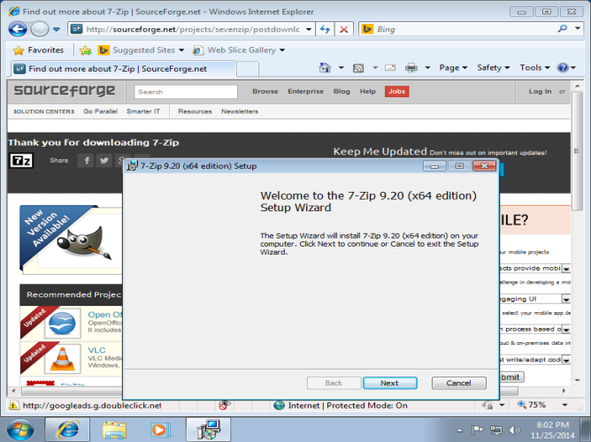

**Step 4)** Click ‘Next’ to see the user agreement. (You have to agree to this to install this program)

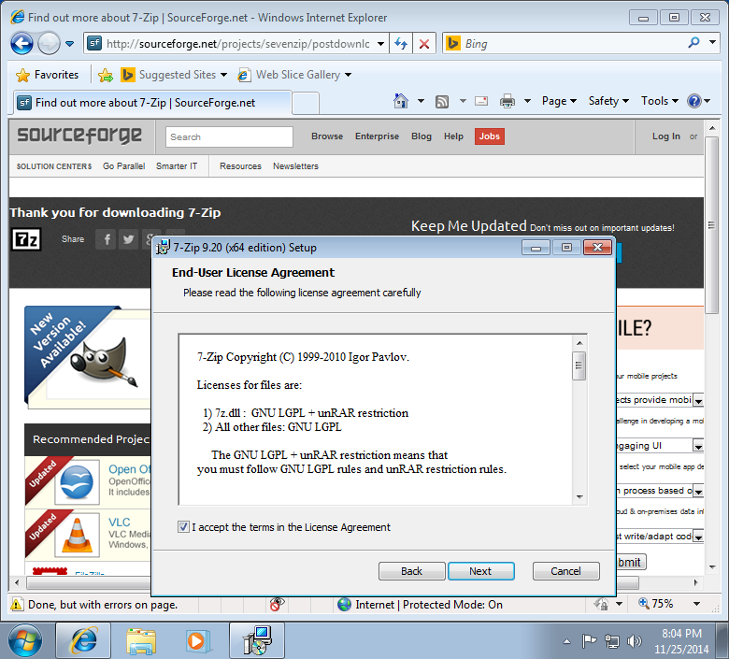

**Step 5)** Click ‘Next’ after you check the box and agree to the license agreement (as shown above) and browse to where you would like install this program. (Leave this in the default location unless necessary)

**Step 6)** Click Next and then Install to begin installation.

**Step 7)** In case a security pop-up comes up asking if it is ok to let an unknown program make changes to the computer, click yes.

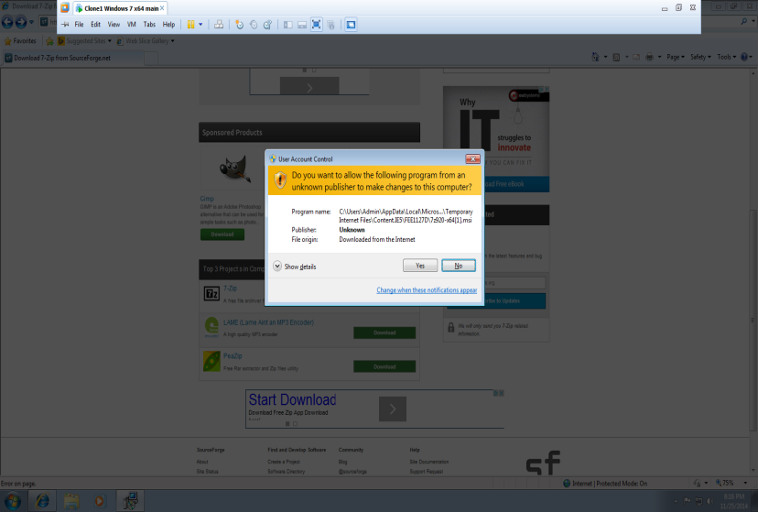

**Step 8)** Click Finish to finish installation

If all of this happens without any issues 7-zip should have been successfully downloaded into your computer.

Disclaimer: This document is for reference purposes only. The author is not responsible for any damage caused by accessing the internet or from downloading files from these sources.

**Sources**

Screenshots by Manu Mathews

Other sources:

7-Zip Website: <http://7-zip.org/download.html>

Download Link:

[http://sourceforge.net/projects/sevenzip/files/7-Zip/9.20/7z920-x64.msi/download?use_mirror=superb-](http://sourceforge.net/projects/sevenzip/files/7-Zip/9.20/7z920-x64.msi/download?use_mirror=superb-                                     dca2)

[dca2](http://sourceforge.net/projects/sevenzip/files/7-Zip/9.20/7z920-x64.msi/download?use_mirror=superb-                                     dca2)

Microsoft Reference: <http://windows.microsoft.com/en-ca/windows/which-operating-system>